Subject
Any aspect of biology

Articles
The article you are summarizing must be on original research conducted by the author(s). Original research is research conducted by the author(s) of the article and is being published for the first time.
Research articles usually contain 5 sections and may contain subsections. The sections are:
- Abstract – this is a very brief summary of the paper
- Introduction – background information and why the research is important
- Materials and Methods – the procedures used by the researchers
- Results – the results of the study
- Discussion – what the results mean and the significance of the study
In addition, the article you summarize must be 7 or more pages in length not counting the works cited but including figures and tables.
Some journals use different names for the sections and sometimes arrange them differently. Each article will have an abstract, which is a summary of the article by the author(s). The abstract is much shorter than what you need to write.
Review articles cannot be used. Review articles summarize information on a particular topic using many research articles as sources. Review articles do not contain the sections noted above.
You may be asked to provide the article you are summarizing after your summary has been turned in.

Journals
Only peer reviewed journals may be used as sources of articles to summarize. Peer reviewed journals are those which publish scientific articles that have been reviewed by scientists knowledgeable in the field of study prior to publication.
Examples of journals that can be used: Biological Bulletin, Marine Biology, American
Naturalist, Plant Physiology, Auk, Cell, Journal of Experimental Biology – there are many many additional journals that can be used
Examples of magazines that cannot be used: National Geographic, Discover, Scientific
American, Popular Science, Science News, American Scientist, anything published by the BBC, and more – popular science publications (such as those listed above) are not peer reviewed journals

Format and length
- Double spaced, except for the article citation
- 12 point font, 1 inch margins, 1 to 2 pages
- Use .doc, .docx, or .odt file formats
- No title page
- The top of the first page should be the citation of the article under review o Citations should be written as a bibliographic reference:
Author(s). Year. Title. Journal Volume: page numbers.
Example:
Page 1 of 2

Biological Discovery extra credit
Nimoy, L and Kelley, D. 1967. Reproduction rate of tribbles varies with food intake. Vulcan Journal of Biology 2: 15-29.
- After the citation, double space then your name
- After your name, double space then your review
I do not grade by length or weight. A well written summary that is 3/4 of a page will be better received than a poorly written summary that is 2 full pages.

Example extra credit summary
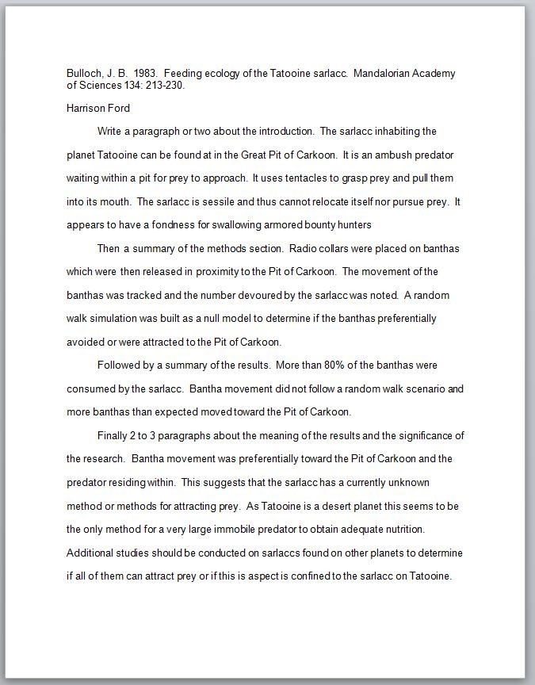
Page 2 of 2

